**Network Diagram Document**

**CECS 491**

**TheBoiZ**

**Lead:**  014073642 Fa Fu

**Members:** 015188925 Brian Nguyen

013122991 Louie Yonzon

015774900 Kevin Simon

015938089 Dylan Thorin

015260958 Kevin Phan

**Date:** November 12, 2019

Table of Contents

**1. INITIAL NETWORK DIAGRAM** **2**

**2. INITIAL COMPONENTS** **3**

2.1 External Network 3

2.2 Internal Network 3

**3. PLANNED NETWORK DIAGRAM** **5**

**4. PLANNED COMPONENTS** **6**

4.1 External Network 6

4.2 Internal Network 6

# **1. INITIAL NETWORK DIAGRAM**

The entire network will use HTTPS port 443 to ensure an encrypted connection.

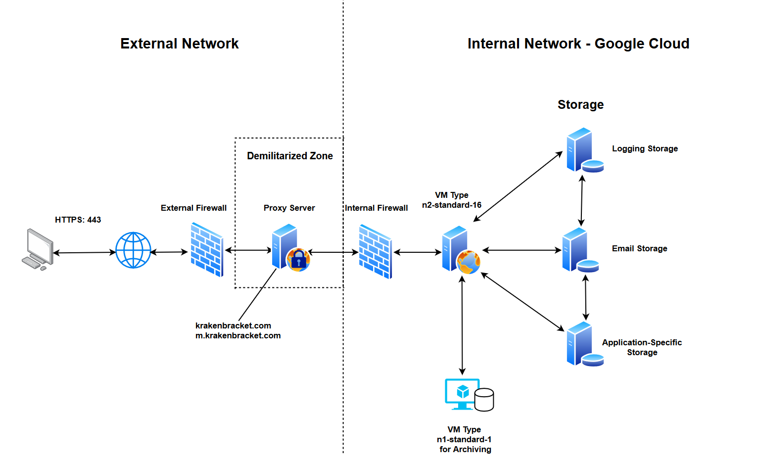

# 2. INITIAL COMPONENTS

## 2.1 External Network

* External Firewall
  + Firewall used as an added layer of security to detect threats before they are able to reach the DMZ
* Demilitarized Zone (DMZ)
  + Network used to detect any malicious activity before it can get inside the internal network, which consists of more sensitive data
  + Proxy server is used for the DMZ. This makes retrieving data from the internet more efficient

## 2.2 Internal Network

* Internal Firewall
  + Firewall used as an added layer of security to detect threats before they can reach the internal network, which consists of sensitive data
  + Ensures that our traffic is coming from our proxy server
* Machine Type n2-standard-16
  + Virtual machine type is hardware resources for a virtual machine from the Google Cloud Service. Different types are offered depending how much resources are needed. Type n2-standard-16 is chosen for this project.
  + This machine will be used for our web server
  + Specifications:
    - vCPU’s: 16
    - RAM: 64 GB
    - Persistent Disks: 128
    - OS: Windows 10
* Virtual Machine for Archiving Logs
  + Virtual machine used for archiving logs starting on the first day of each month. All logs will be stored in a data store and a flat file
  + Google Cloud machine type n1-standard-1 will be used
  + Specifications:
    - vCPU’s: 1
    - RAM: 3.75 GB
    - Persistent Disks: 128
    - OS: Windows 10
* Storage
  + Logging Storage - used to store console logs. These logs will later be archived at the start of each month
  + Email Storage - used to store all users’ email addresses
  + Appication-Specific Storage - used to store data that are specific to the Kraken Bracket app. These include, but not limited to, Tournament Brackets, Events, user profiles, etc.

# 3. PLANNED NETWORK DIAGRAM

The entire network will use HTTPS port 443 to ensure an encrypted connection.

# 

# 4. PLANNED COMPONENTS

## 4.1 External Network

Components have not changed from the initial network diagram

## 4.2 Internal Network

We intend to have dedicated servers for different services. Each server will provide faster services as they are tuned to do what they are created for. By having multiple servers in the networks, they will alleviate stress from our main server.

* File Transfer Protocol Server (FTP)
  + Used to securely transfer files across the network
* Mail Server
  + Used to have our own email domain.
  + More efficient mailing service. Instead of going through another provider, the Email goes directly to our domain.
* Real-Time Communication server (RTC)
  + Allows users to communicate through instant messaging.
  + Faster response to Customer in need of support